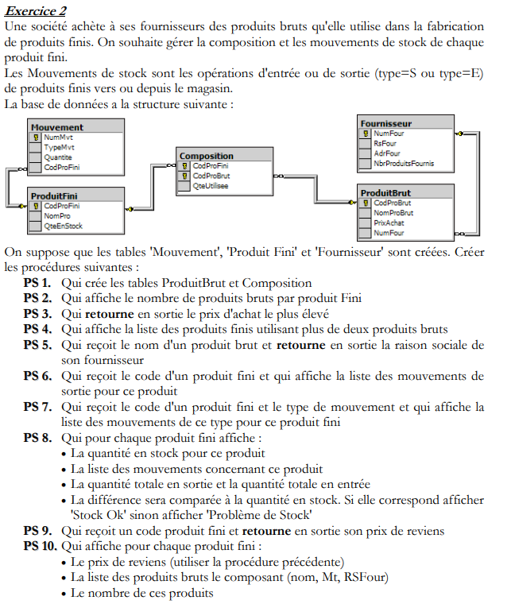

CREATE DEFINER=`root`@`localhost` PROCEDURE `ps2`() [NOT](http://127.0.0.1:84/phpmyadmin/url.php?url=https://dev.mysql.com/doc/refman/8.0/en/logical-operators.html%23operator_not) DETERMINISTIC CONTAINS SQL SQL SECURITY DEFINER BEGIN [select](http://127.0.0.1:84/phpmyadmin/url.php?url=https://dev.mysql.com/doc/refman/8.0/en/select.html) pf.NumProFini,pf.NomPro, [count](http://127.0.0.1:84/phpmyadmin/url.php?url=https://dev.mysql.com/doc/refman/8.0/en/aggregate-functions.html%23function_count)(c.NumProBrut) as 'Nbr produit brut' from compsition c, produitfini pf WHERE c.NumProFini=pf.NumProFini GROUP by pf.NumProFini,pf.NomPro; end

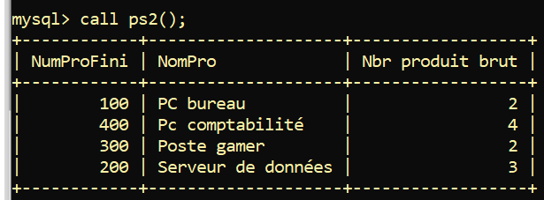

DELIMITER $$

CREATE PROCEDURE ps3(out PrixMax int)

BEGIN

select max(pr.PrixAchat) into prixMax from produitbrut pr;

end

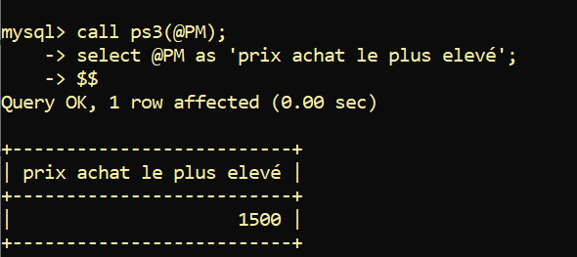

DELIMITER $$

CREATE PROCEDURE ps4()

BEGIN

select pf.NumProFini,pf.NomPro, count(c.NumProBrut) as 'Nbr produit brut utilisé'

from compsition c, produitfini pf

where c.NumProFini=pf.NumProFini

GROUP by pf.NumProFini,pf.NomPro

HAVING count(c.NumProBrut) >=2;

end$$

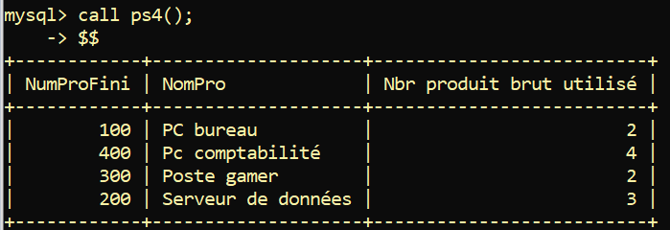

[CREATE](http://127.0.0.1:84/phpmyadmin/url.php?url=https://dev.mysql.com/doc/refman/8.0/en/create-procedure.html) [PROCEDURE](http://127.0.0.1:84/phpmyadmin/url.php?url=https://dev.mysql.com/doc/refman/8.0/en/create-procedure.html) ps5([IN](http://127.0.0.1:84/phpmyadmin/url.php?url=https://dev.mysql.com/doc/refman/8.0/en/comparison-operators.html%23function_in) NomProBrut varchar(30) ,OUT rs varchar(50)) BEGIN [select](http://127.0.0.1:84/phpmyadmin/url.php?url=https://dev.mysql.com/doc/refman/8.0/en/select.html) f.RsFour into rs from produitbrut pr, fournisseur f where pr.NumFour=f.NumFour [and](http://127.0.0.1:84/phpmyadmin/url.php?url=https://dev.mysql.com/doc/refman/8.0/en/logical-operators.html%23operator_and) pr.NomProBrut [like](http://127.0.0.1:84/phpmyadmin/url.php?url=https://dev.mysql.com/doc/refman/8.0/en/string-comparison-functions.html%23operator_like) NomProBrut; end;

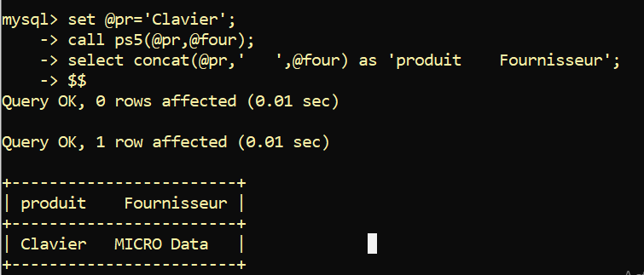

[CREATE](http://127.0.0.1:84/phpmyadmin/url.php?url=https://dev.mysql.com/doc/refman/8.0/en/create-procedure.html) [PROCEDURE](http://127.0.0.1:84/phpmyadmin/url.php?url=https://dev.mysql.com/doc/refman/8.0/en/create-procedure.html) ps6([IN](http://127.0.0.1:84/phpmyadmin/url.php?url=https://dev.mysql.com/doc/refman/8.0/en/comparison-operators.html%23function_in) code_PF int)   
BEGIN   
[select](http://127.0.0.1:84/phpmyadmin/url.php?url=https://dev.mysql.com/doc/refman/8.0/en/select.html) m.NumMvt, m.typeMvt,m.Quantite   
from mouvement m   
where m.NumProFini=code_pf   
[and](http://127.0.0.1:84/phpmyadmin/url.php?url=https://dev.mysql.com/doc/refman/8.0/en/logical-operators.html%23operator_and) m.typeMvt [like](http://127.0.0.1:84/phpmyadmin/url.php?url=https://dev.mysql.com/doc/refman/8.0/en/string-comparison-functions.html%23operator_like) 'S';   
end;

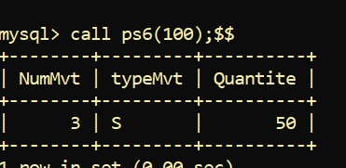

DELIMITER $$

CREATE PROCEDURE ps7(code_PF int, TM char)

BEGIN

select m.NumMvt, m.typeMvt,m.Quantite

from mouvement m

where m.NumProFini=code_pf

and m.typeMvt like TM ;

end$$

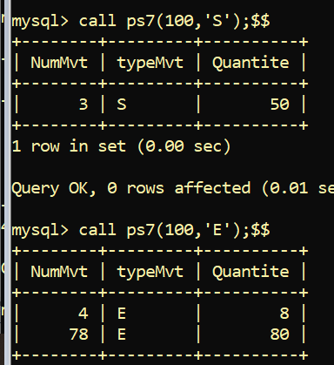

DELIMITER $$

CREATE PROCEDURE ps9(IN code_PF int, out prixRev int)

BEGIN

select c.NumProFini , sum(c.QteUtilisee * pbr.PrixAchat) into prixRev

from compsition c ,produitbrut pbr

where c.NumProBrut=pbr.NumProBrut

and c.NumProFini= code_PF;

end$$

